

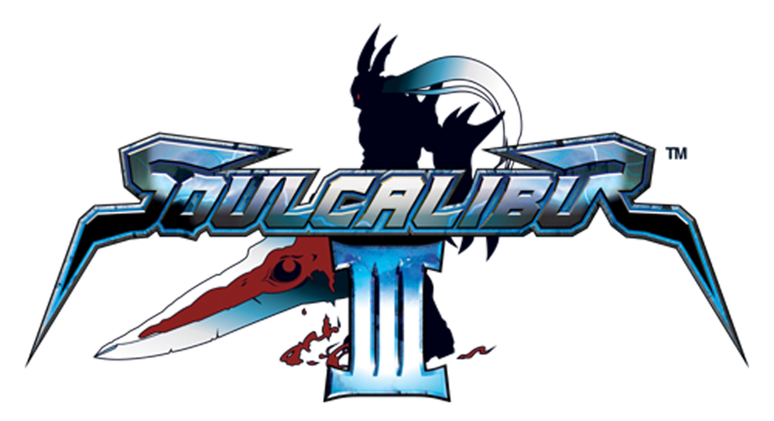

Creating a character Q&A’s - Seido Ozawa, Chief Designer

- Name, position & length of time working on ‘creating characters’?

Seido Ozawa, Chief Designer, around 1 and half years (since beginning of the SCIII project and Character Creation)

- Favourite Soulcalibur III character – who and why

Maxi
Maxi has an attractive and unique set of motions using the nunchaku, different even when compared to the other SOULCALIBUR characters. Just watching how the nunchaku moves is interesting.

- What is your exact role/ contribution in the development of a character?

This feature is new to the series so the SOULCALIBUR team did not have the technical know-how of a character customization system. So the programmers and developers got together and collectively developed a system where you can change your character’s clothes and wear layers of clothes.
We started from scratch for we had nothing to build on, so we had really had to create individual equipment, clothes and items efficiently. My role in this was to plan the schedule, set up and manage the work process and finally check the quality of the finished items.

- Where does the inspiration come from when beginning the process of character creation?

The producer Yotoriyama-san was the one that brought this concept to life and established the mode. With his strong determination, he was the catalyst in infusing a new mode in an established series, something that is not easy to do – all a result of his accurate decision making based on a wide vision with an understanding of both player and developer needs.

With regards to the design, I receive much inspiration from the character designer Kawano-san, who has designed many of the SOULCALIBUR III characters. The process starts by dividing Kawano-san’s design into separate parts, which is done by the character creation modellers, myself included. When we divide the parts we constantly ask, how should clothes designed like this be modelled? If necessary, the modeller will arrange the design. Kawano-san designs very quickly and has lots of ideas. He is a great designer. He was an integral part of this feature which makes me think that Character Creation would not be a success without him. Kawano-san would design and then the creation modeller actualizes his designs – a great combination done very efficiently. I would love to work with him again!

  - do you begin with an idea for a weapon and then build the character around it?

There are cases where we try to fit various weapons in one character and also cases where we create a character with a weapon in mind. It is a process that also involves the story and moves of the character so we have to be flexible. We have to really grind it out at this junction to create appealing characters. The characters, the story, the weapon, the moves and motions are all very important aspects of the SOULCALIBUR series and so we all spend much of our time contemplating which direction to take the series.

  - do you design the costume as well as the character, or does someone else do the costume design?

As mentioned previously, in Character Creation Kawano-san designed the costume and the faces were done by the regular character design team because the face really shows the character’s individuality. For the Chronicles of the Sword mode, Kawano-san designed both the character and costume.

  - what are the basic rules you have to follow when creating a new character – is there anything you are not allowed to do/ create?

The character has to be attractive using weapons.
The character has to look cool in action.

The above points come to mind but there are basically no restrictions. Although it is not a written rule, I am always conscious of creating new characters that can stand alone and are not overshadowed by the classic characters because the series has so many characters that are all very unique.

  - are you responsible for one or more characters?

We create part of characters in Character Creation mode so that it is calculated by parts not characters. We create more than 100 parts each.

- What is the most difficult part of creating a character and which character was the most difficult to create?

I can’t give a simple answer but perhaps expressing complex fabrics and abundant hair on the characters are the most difficult.

- How long does it take for a character to come to life on screen – how long does it take from the idea to the actual playable character?

At the shortest probably one week. We have to make many adjustments and add the finishing touches to the design so in all maybe about a month or so. It takes much more time to actually be able to play as other factors become involved such as motion.

- Have you ever created a character that did not work very well as a playable character, and had to make big changes to it or put it aside for a future iteration of the game?

Sometimes it happens. I feel it is more likely to happen when the 3-D image is not clear at the design stage. But there is always a way to incorporate what you made so there is always a use to those designs.

- When you create a character, do you make up a history/ story/ motivation for them?

The story is very important to the SOULCALIBUR series, an essential process in creating a character. We work very closely with the creators of the story – confirming and adjusting even the smallest of details.

- Why do you think certain characters are more popular than other ones?

If there is such a thing, I would think that it is because certain characters attract wide range of people and other characters attract core gamers. However, I feel that the different type of characters compliment each other by bringing out the best of each other and thus highlighting each others storyline. Another thing is the popularity of characters differs in different countries. Subsequently, just a few factors do not determine the popularity of a character.

- What is your favourite special move?

I like the moves of Maxi, the character that I normally use. Maxi’s nunchaku actions are distinct, very fluid and constantly in motion. I like how you can seamlessly string his moves into one fluent motion.

- With games consoles getting more powerful, what do you think will be the next big breakthrough in character creation?

We have many ideas to expand the Character Creation system but we are not at a stage where I can disclose what we’re working on. At the least I hope to raise the quality and also add many more new features.
With games consoles getting more powerful, I think there is room for improvement in many factors such as more detailed facial expressions, muscle movement, expression of fabric and hair and texture.

- How do you get the movement of the characters so fluid?

It is due to the programmer and motion designer’s time and effort. The character modellers also take great care to create models that do not deform even during the most violent moves.

Character creation mode

- Everyone is talking about the new character creation mode in Soulcalibur III. Can you tell us whose idea it was to create this?

It all started from the producer Yotoriyama-san.

- What was the most difficult part of making this feature a reality?

First, I have to say that this project worked brilliantly as a group. Because this was a new system, the team came across many new challenges. For example, the changing of clothes and parts, wearing layers, the shear number of equipment, clothes, items and managing all these things into a cohesive process. We were able to overcome all obstacles with the hard work from all our project members because the project worked as a united team, not a group of individuals.

- You have begun to introduce ‘emotion’ into the characters – is this something you would like to develop further?

Yes it is. Hardware will continue to advance and we, as developers, will have to contemplate more than ever how to utilize that expressiveness the added power brings to games.
It is an even more critical issue because the technical margin between software companies is basically non-existent. Without that technical differentia, I feel it will come down to being able to persuasively convey a more human aspect, the character’s personality and the inner facet – which has not yet been specifically and clearly developed. Simply having a realistic and beautiful look, surface or texture is no longer enough.
The SOULCALIBUR team has paid particular attention to displaying facial features and we have many members that excel in handling this sensitive work so I think this is an area that we can continue to present with confidence. Furthermore, I hope to support this area of work.

- In character creation mode, you are allowing the gamer to ‘do your job’ – are you worried that people will not want to play your characters any more?

Not at all and the reason is simple: Regular characters have a defined image with their specific storyline and background settings and the characters strength lies in that carefully cultivated image. On the contrary, custom characters do not have that defined image, much of that control is left to the freedom of the player. So players can freely enjoy and control their new creations without the limitation of a defined character image.
As you can see, the appeal of the two features compliment each other – each brings a quality neither has.
Players can choose to enjoy the compelling stories that are carefully crafted by creators by operating the standard characters or players can choose to test their creativity and imagination through their own creation within the SOULCALIBUR universe. The SOULCALIBUR III package offers an extremely diverse and wide range of characters, all in one game.
As a game creator, I hope the standard characters and custom characters compete against each other, helping each other develop to become even more attractive features. And I hope we can provide many more options for players so they can make selections depending on how they feel that day.

- Can you give us some hints/ tips about creating a character?

The Character Creation mode in SOUCALIBUR III gives you much freedom so you can kind of go wild with that, get excessive and choose several colours and various parts. But too many elements and you lose the cohesiveness of the overall design so reining in that urge to go wild, limit the number of colours and parts and you’ll get a more coherent character. As you get used to the system, you’ll learn to add more elements without losing the overall clarity.

- If you were judging a character creation competition, what qualities would you look for in the winner?

Because you can express yourself in so many different ways in the Character Creation mode, you would need many different types of awards. An award for the most eccentric character, another for the cutest, or the sexiest, you could categorize by the look such as characters with an Asian look, characters with armour, skin headed characters, characters with a sophistically coordinated look…I can think of many criteria. All in all, I just hope that players also think of countless awards and find creative ways to enjoy playing the game.

- Can you tell us something about one of your characters that no-one else knows?

In short, the Character Creation team made many different items in the Character Creation Mode. I don’t think anyone knows all the combinations that can come out when selecting parts, myself included! I would love to hear of players spending hours enjoying the mode and then telling us of all the discoveries that they’ve made.

Visit our website:
www.soulcalibur-3.com

Notes to Editors

Developer: Namco Genre: Sword-fighting Action
No. of Players: 1-2 Platform: PlayStation®2
Peripherals: Analog Controller (DUALSHOCK®2), Memory Card (8MB) (for PlayStation®2)
Release Date: Quarter 4, 2005

About Sony Computer Entertainment Europe Ltd.
Sony Computer Entertainment Europe (SCEE), based in London, is responsible for the distribution, marketing and sales of PS one®, PlayStation®2 and PlayStation® Portable software and hardware in 104 territories across Europe, the Middle East, Africa and Oceania. SCEE also develops, publishes, markets and distributes games software for the three formats, and manages the third party licensing programs for these platforms in the PAL territories. At the end of June 2005, over 40 million PlayStation® units had been shipped across these PAL territories, over 102 million worldwide. Between its European debut on 24 November 2000 and 20th July 2005, over 33 million PlayStation®2 units have been shipped across the PAL territories, over 91 million world-wide, making it one of the most successful consumer electronic products in history. Between the launch of the PSP in Japan in December 2005 and 21 July 2005, over 5 million PSPs have been shipped worldwide.

PlayStation and the PlayStation logo, PS one and PS2 are registered trademarks of Sony Computer Entertainment Inc. PSP and UMD (Universal Media Disc) are trademarks of Sony Computer Entertainment Inc. All other trademarks are property of their respective owners.

More information about PlayStation products can be found at http://www.scee.com , www.yourpsp.com and www.playstation.com or visit the Virtual Press Office at www.scee.presscentre.com

Namco Limited
Namco, with headquarters in Japan was established in 1955 and has consistently provided a high level of expertise in the entertainment industry. With games such as Tekken™, Ridge Racer™, Timecrisis™ and Acecombat™, Namco has become a successful developer and publisher, esteemed throughout the world for the games of excellent quality it has produced.

Tekken™, Ridge Racer™, Timecrisis™ and Acecombat™ are trademarks or registered trademarks of Namco Limited. Namco is a registered trademark of Namco Ltd. All rights reserved.SOULCALIBUR™III & ©1995 1998 2002 2003 2005 NAMCO LTD., ALL RIGHTS RESERVED.
NAMCO is a registered trademark of NAMCO LTD. All other trademarks and trade names are the properties of their respective owners.

